Name: ___Damion Samuels____

Lesson 9: Insert and Update

1. **Create** a table with the following parameters:
   * CustomerID
   * CustomerName
   * Address
   * City
   * PostalCode
   * Country
   * Email

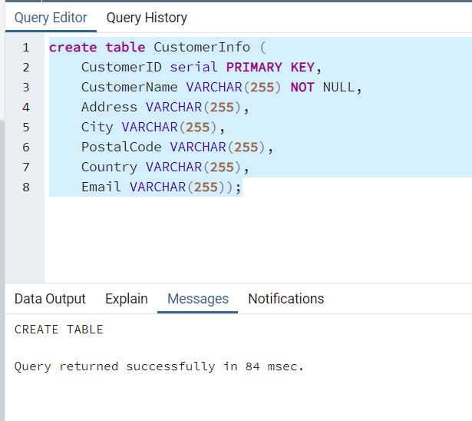

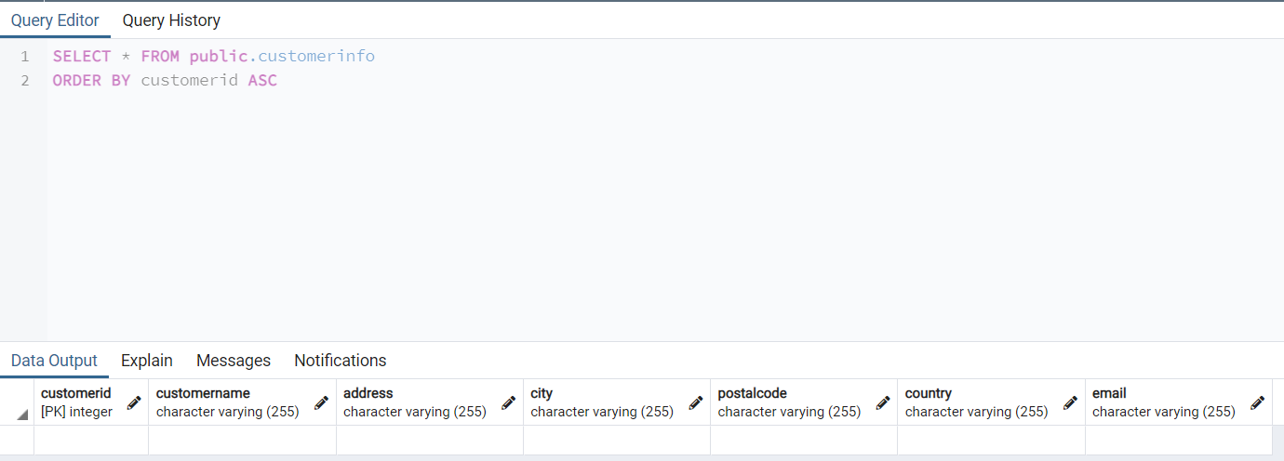

1. Insert 3 rows of data into these columns using **INSERT**. The data you insert should make sense for the column.

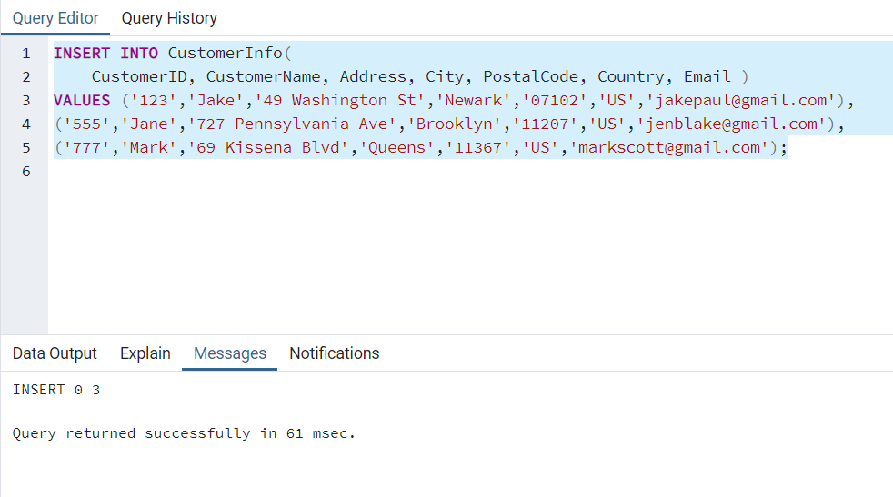

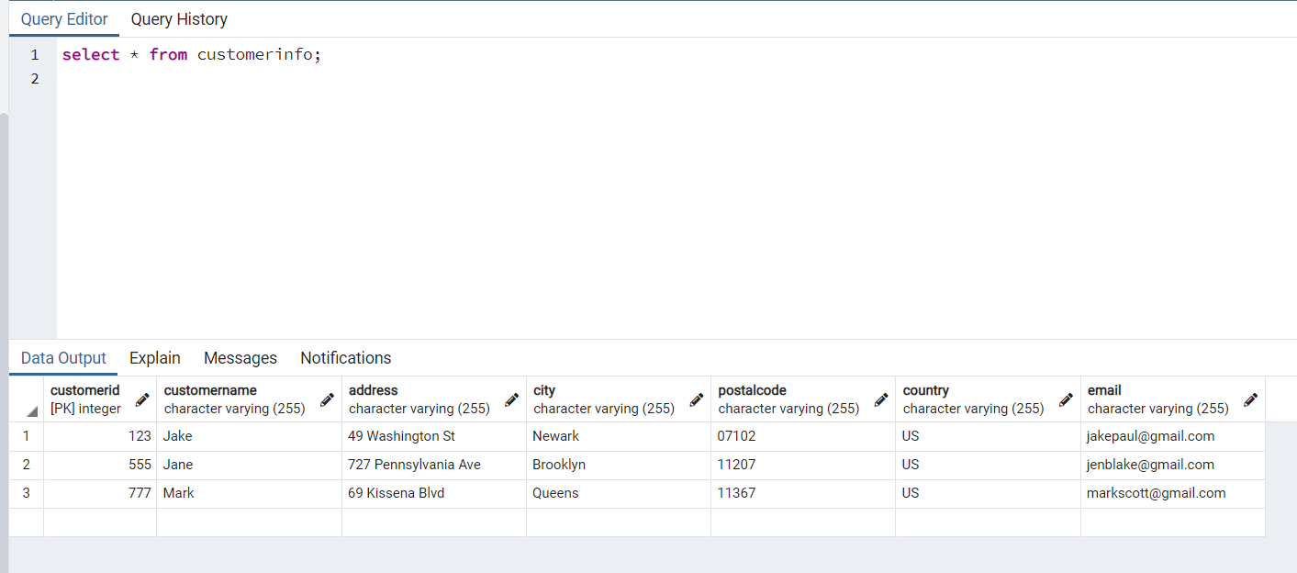

1. Use an **UPDATE** to modify any portion of the data

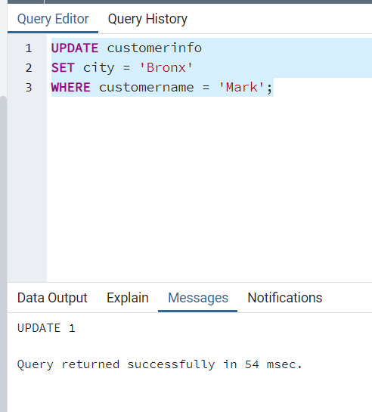

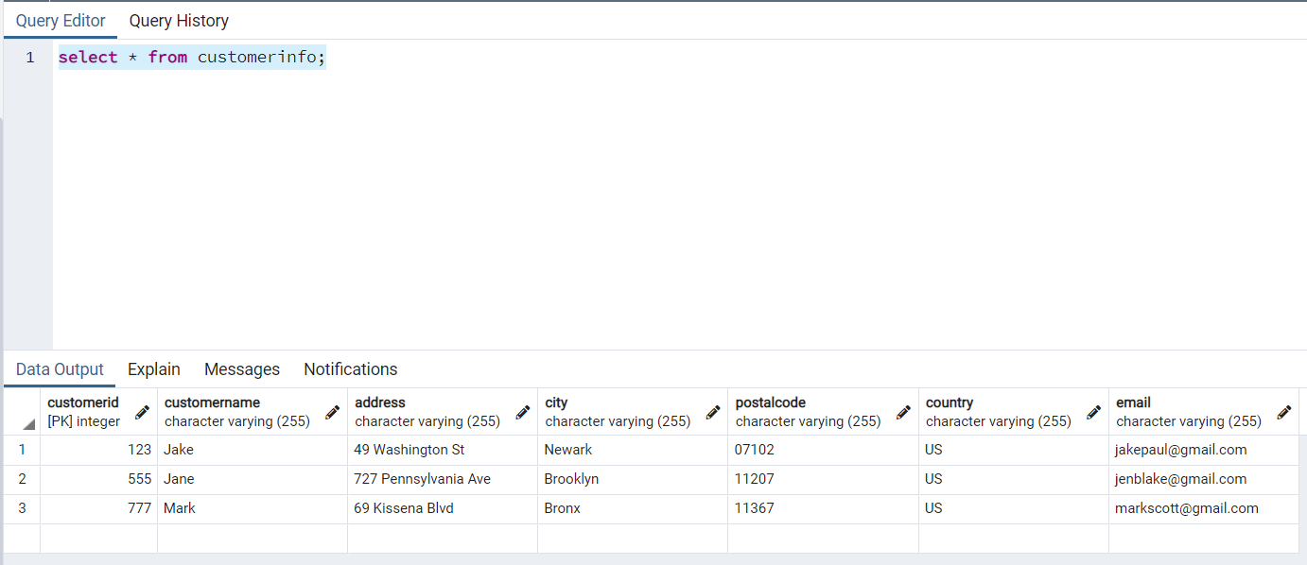

1. Finally, write a statement to **delete** one row of data.

